# Preliminary DSS Installation instructions.

Notes the DSS currently requires a Windows 64bit computer. These interim instructions will be replaced with a more streamlined process once the DSS is finalized and ready to be released to a wider audience.

1. Download the software and initial data zips from: <https://www.sciencebase.gov/catalog/folder/55a7d7b0e4b0183d66e45f64>
2. Install the software
   1. Unzip the software.zip into your c:\temp directory.
   2. Install MapWinGIS 4.8 from the installer MapWinGIS-only-v4.8SR-64bit-installer.exe (also available from: https://mapwingis.codeplex.com/releases/view/76527)

This installation required administrative privileges on the computer. Accept the defaults and accept the license.

* 1. Make sure the folder called “HavasuDSS_deploy” unzipped directly under your c:\temp directory. If not move it there as this interim installer will look for the files it needs at this specific location.

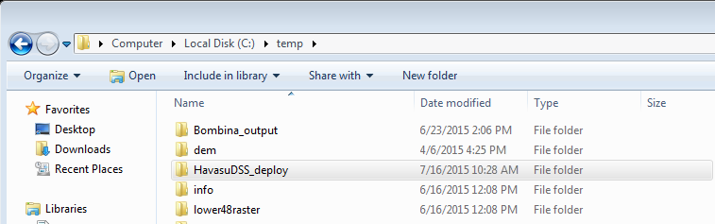

* 1. In the HavasuDSS_deploy folder double click the setup.exe file. (This does not require administrative privileges.) Click “Install”. The application will open up but you’ll need to unzip and point to the data before you can use it, instructions below.
  2. In the future you can open the application from the windows start menu:

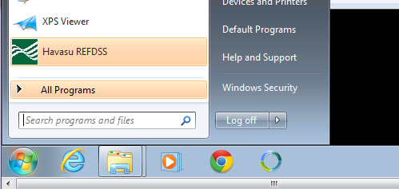

1. Unzip the initial data files. It doesn’t matter where these are unzipped to, but it would make sense to move these files into a permanent project workspace.
2. Within the DSS application a message box has likely popped up saying that the DSS needs data. Click ok to dismiss this window and the main form will open up.
   1. From the main File menu in the application click on “Change Input Data Directory” and navigate to the “Inputs” folder in the “data” folder you unzipped.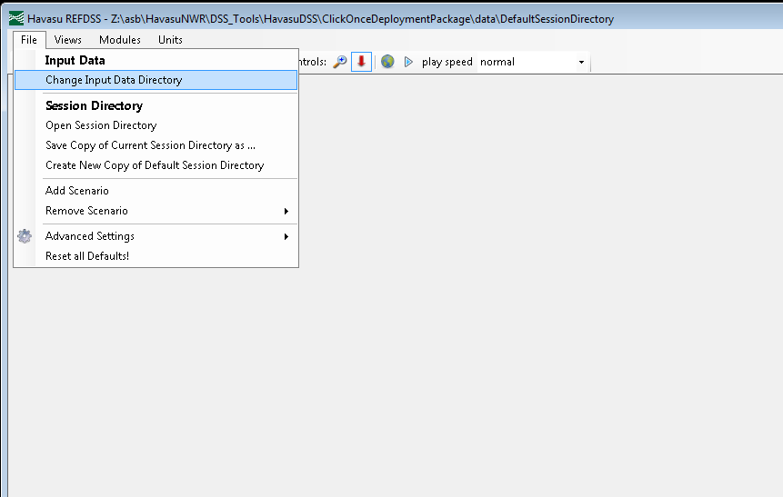
   2. Likewise click on “Open Session Directory” and navigate to the “DefaultSessionDirectory” in the “data” folder you unzipped. After doing this click ‘no’ on the message box that pops up asking you to calculate the spatial outputs.